If 2 devices are connected, that counts as a network
Networks mut be consistent and standard
HTML counts for this
Protocols need to be revisited, POP and whatever
What on earth is a UDP

Layers
Application
Transport
Internet
Data link
Physical

Open systems interconnection model (OSI)
Application
Presentation
Session
Transport
Network
Data link
Physical

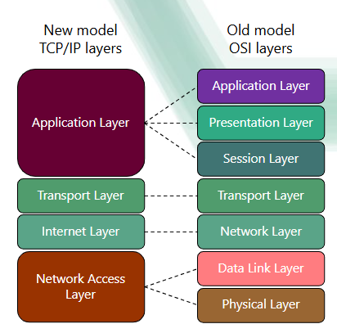

Data is split up into packets
Gaps in knowledge here()()()
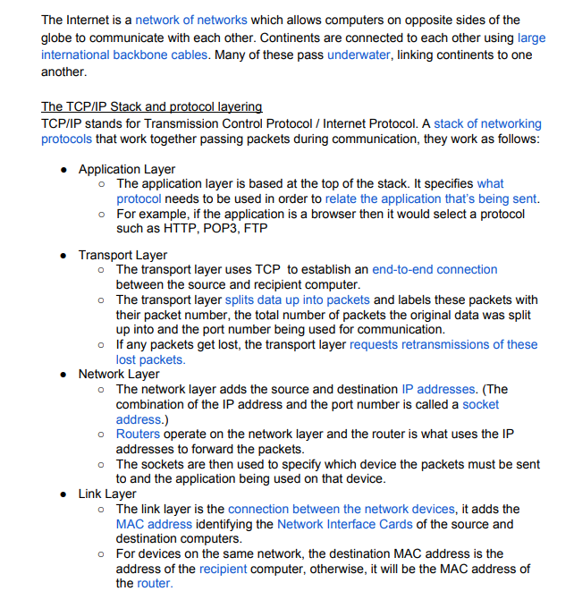
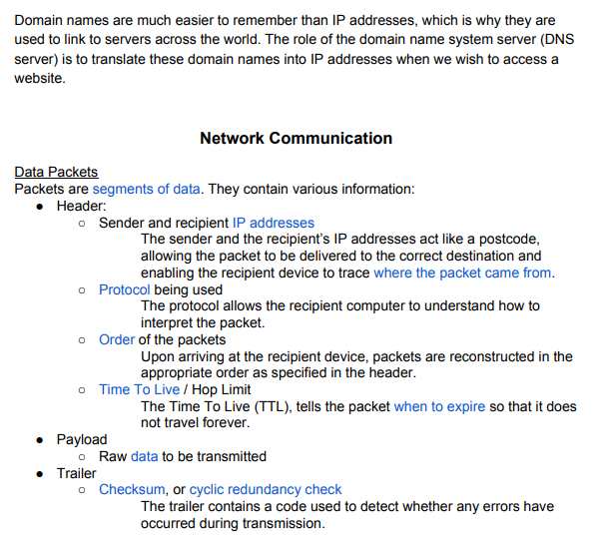
IP addresses / MAC addresses
MAC – Media address control
MAC address fixed to a device
IP address dynamic
MAC Address linked to IP Address

Router is on a WAN
LAN looks at MAC addresses
Oh my fucking god this teacher is worthless
WAN looks at IP address

